模块呈现形式

https://www.wellsfargo.com/help/loans-and-lines/student-payments-billing-fees-faqs/

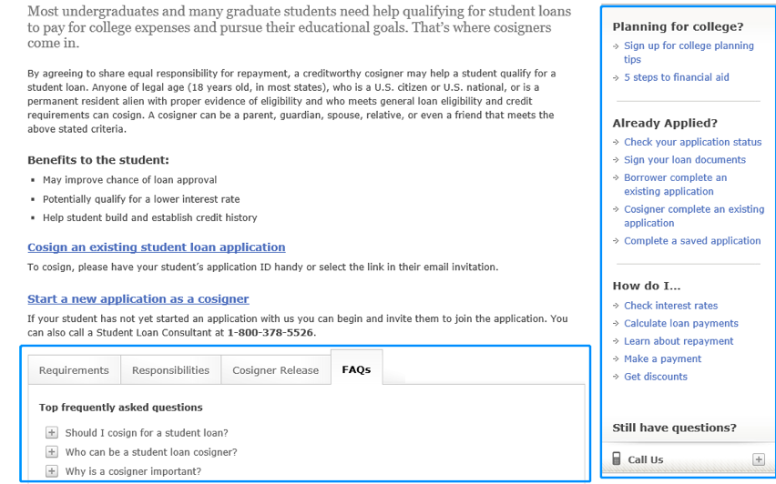

模块内容

FAQS

Recommended questions

Can I change my payment due date?

If you are the primary borrower and your payment due date is causing difficulty, please contact us at 95566 (mainland) or +86 (area code) 95566 (overseas or Hong Kong, Macao and Taiwan)

­How is my loan issued?

Once approved, your personal loan for studying abroad will be legally paid according to Interim Measures for the Administration of Personal Loans and its actual use. Details refer to the rule drawn up by local outlets of Bank of China.

How do I find an outlet location, hours of operation or contact info for an outlet?

Details referring to the outlets can be discovered in the file below.

What does the list of overseas higher educational institutions authorized by Ministry of Education include?

Details referring to the list can be discovered on JSJ’s official website (http://www.jsj.edu.cn/n1%2F12018.shtml).

 What if I miss a payment or make a late payment?

If a payment is missed or paid late, a late will be assessed if the current payment and past due (if any) amount is not paid before the applicable payment grace period expires and the delinquency may be reported to the consumer reporting agencies as past due. Additionally, the delinquency will mar your credit report in the long term.